EXPERIMENT NO. 01

# **Aim:- Use of Basic Tags**

**Markup language Used:-**

**What is html:-**

* HTML stands for Hyper Text Markup Language
* HTML is the standard markup language for creating Web pages
* HTML describes the structure of a Web page
* HTML consists of a series of elements
* HTML elements tell the browser how to display the content
* HTML elements label pieces of content such as "this is a heading", "this is a paragraph", "this is a link", etc.

**What is css:-**

* CSS stands for Cascading Style Sheets
* CSS describes how HTML elements are to be displayed on screen, paper, or in other media
* CSS saves a lot of work. It can control the layout of multiple web pages all at once
* External stylesheets are stored in CSS files

**Theory about tags used:-**

The [<b>](https://www.w3docs.com/learn-html/html-b-tag.html) tag is a physical tag that stands for bold text, whereas the [<strong>](https://www.w3docs.com/learn-html/html-strong-tag.html) tag being a logical tag is used to emphasize the importance of the text.

The [<i>](https://www.w3docs.com/learn-html/html-i-tag.html) and [<em>](https://www.w3docs.com/learn-html/html-em-tag.html) tags define italic text. The <i> tag is only responsible for visual appearance of the enclosed text, without any extra importance. The <em> tag defines emphasized text, with added semantic importance.

The [<pre>](https://www.w3docs.com/learn-html/html-pre-tag.html) tag is used to define preformatted text. The browsers render the enclosed text with white spaces and line breaks.

The [<mark>](https://www.w3docs.com/learn-html/html-mark-tag.html) tag is used to present a part of text in one document as marked or highlighted for reference purposes.

The [<small>](https://www.w3docs.com/learn-html/html-small-tag.html) tag decreases the text font size by one size smaller than a document's base font size (from medium to small, or from x-large to large). The tag usually contains the items of secondary importance such as copyright notices, side comments, or legal notices

The [<del>](https://www.w3docs.com/learn-html/html-del-tag.html) tag specifies a part of the text that was deleted from the document. Browsers display this text as a strikethrough

The [<s>](https://www.w3docs.com/learn-html/html-s-tag.html) tag defines text that is no longer correct, or relevant

The [<ins>](https://www.w3docs.com/learn-html/html-ins-tag.html) tag defines the text that has been inserted (added) to the document. The content of the tag is displayed as underlined

The [<u>](https://www.w3docs.com/learn-html/html-u-tag.html) tag specifies text that is stylistically different from normal text, i.e. words or fragments of text that need to be presented differently. This could be misspelled words or proper nouns in Chinese

The [<sub>](https://www.w3docs.com/learn-html/html-sub-tag.html) defines subscript texts. Subscript text is under the baseline of other symbols of the line and has smaller font. The [<sup>](https://www.w3docs.com/learn-html/html-sup-tag.html) tag defines superscript, that is set slightly above the normal line of type and is relatively smaller than the rest of the text. The baseline passes through upper or lower edge of the symbols.

The [<dfn>](https://www.w3docs.com/learn-html/html-dfn-tag.html) tag is used to define the term, that is mentioned for the first time. The content of the tag is displayed in italic.

The [<p>](https://www.w3docs.com/learn-html/html-p-tag.html) tag defines the paragraph. Browsers automatically add 1em margin before and after each paragraph

The [<br>](https://www.w3docs.com/learn-html/html-br-tag.html) tag inserts a single line break. Unlike the <p> tag an empty indent is not added before the line.

In HTML5 the [<hr>](https://www.w3docs.com/learn-html/html-hr-tag.html) tag defines a thematic change between paragraph level elements in an HTML page. In previous versions of HTML it was used to draw a horizontal line on the page visually separating the content. In HTML5 the element has semantic meaning

anchor tag:-

The most important attribute of the <a> element is the href attribute, which indicates the link's destination.

## **Inline CSS**

* An inline CSS is used to apply a unique style to a single HTML element.
* An inline CSS uses the style attribute of an HTML element.

## **Internal CSS**

* An internal CSS is used to define a style for a single HTML page.
* An internal CSS is defined in the <head> section of an HTML page, within a <style> element.

## **External CSS**

An external style sheet is used to define the style for many HTML pages.

**a. Design a web page using different text formatting tags.**

**Code:-**

<!DOCTYPE html>

<html>

<head>

<title>different text formatting tags</title>

</head>

<body>

<hgroup>

<h1>heading1</h1>

<h2>heading2</h2>

</hgroup>

<p>Lorem Ipsum is simply dummy text,...</p>

<blockquote>

    tLorem Ipsum is simply dummy tex of the printing and typesetting industry<br>

    Lorem Ipsum is simply dummy text of the printing and typesetting industry<br>

    Lorem Ipsum is simply dummy text of the printing and typesetting industry<br>

    Lorem Ipsum is simply dummy text of the printing and typesetting industry<br>

</blockquote><br>

<b><i>hello DMCE</i></b>

h<sub>2</sub>so<sub>4</sub><br>

(a+b)<sup>2</sup>=a<sup>2</sup>+2ab+b<sup>2</sup><br>

h<sub>2</sub>o<br>

<kbd>hello</kbd><br>

<code>hello</code><br>

<samp>hello</samp><br><br>

<pre>Lorem Ipsum is simply dummy text of the printing and typesetting industry.

</pre><br><br>

</body>

</html>

**Output:-**

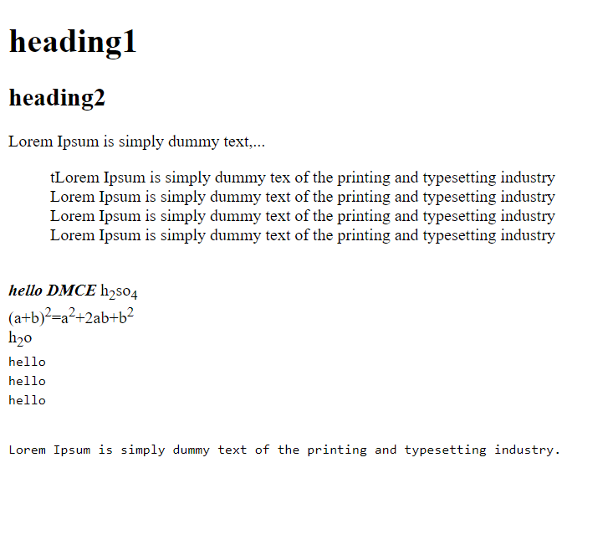

**b. Design a web page with links to different pages and allow navigation between web  
pages.**

**Code:-**

**File1:-**

<!DOCTYPE html>

<html>

<haed>

<title>One</title>

</head>

<body>

<a href="design.html">Go to Design page</a>

</body>

</html>

**Output:-**

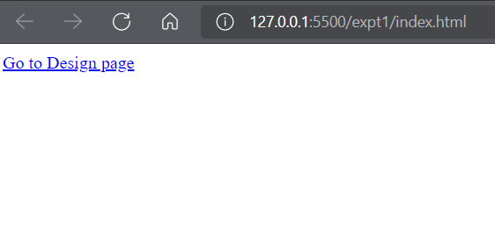

**File 2:-**

<!DOCTYPE html>

<hrtml>

<head>

<title>Text</title>

</head>

<body>

Welcome to design.html.

<br>

<a href="home.html">Go to home</a>

</body>

</html>

**Output:-**

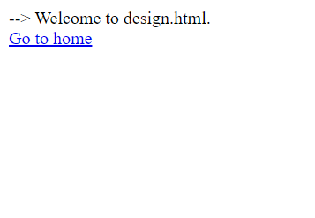

**File 3:-**

<!DOCTYPE html>

<hrtml>

<head>

<title>text</title>

</head>

<body>

Welcome to Hyperlinks.

</body>

</html>

**Output:-**

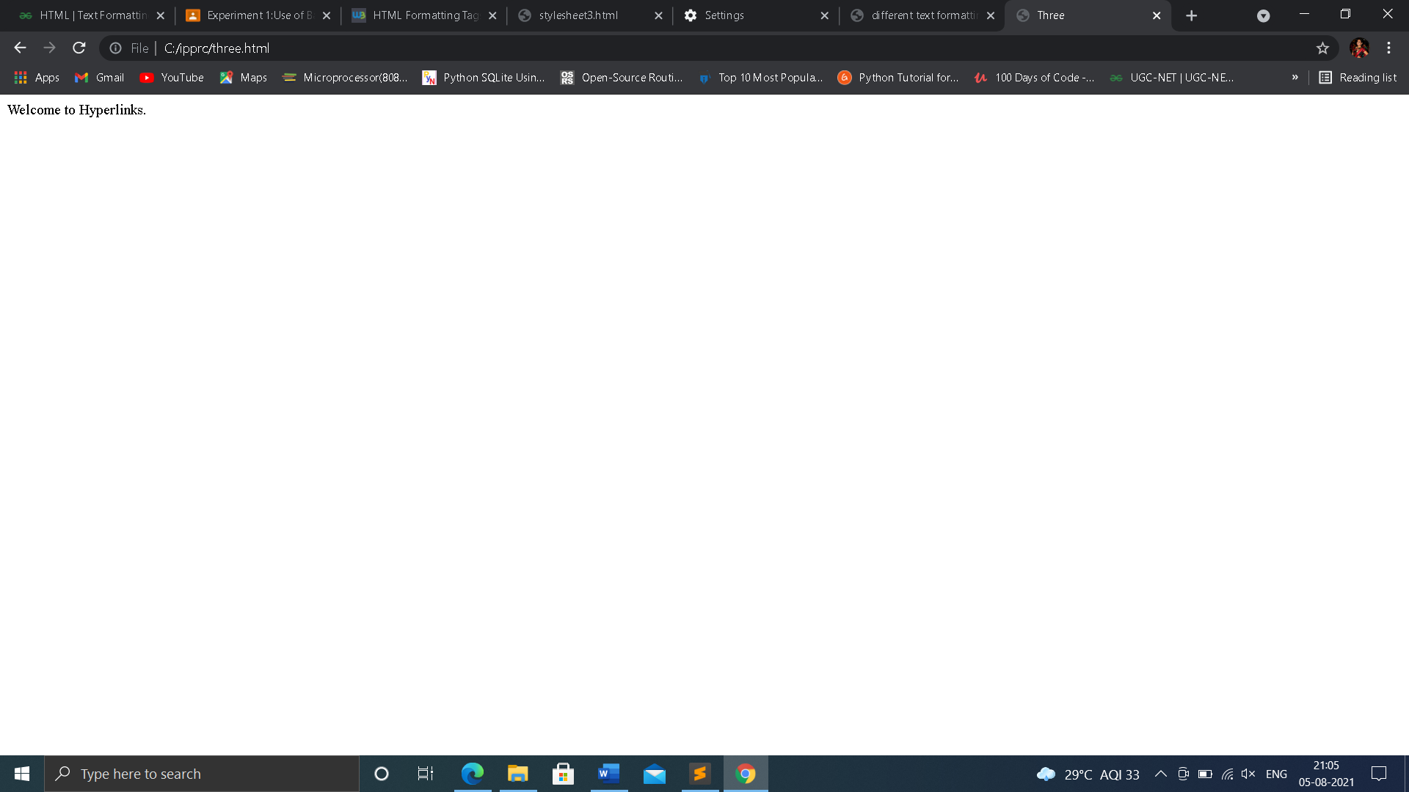

**c. Design a web page demonstrating all Style sheet types**

**code:-**

**inline css:-**

<!DOCTYPE html>

<html>

    <head>

        <title>Inline CSS</title>

    </head>

    <body>

        <p style = "color:#998a0070; font-size:50px;

                font-style:italic; text-align:center;">

            TE_B_03

        </p>

    </body>

</html>

**Output:-**

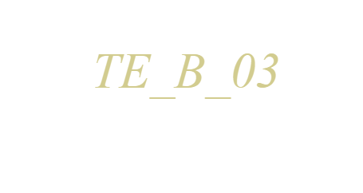

**Internal or embedded css:-**

<h<!DOCTYPE html>

tml>

    <head>

        <title>Internal CSS</title>

        <style>

            .main {

                text-align:center;

            }

            .TE {

                color:#009900;

                font-size:50px;

                font-weight:bold;

            }

            .STUDENT {

                font-style:bold;

                font-size:20px;

            }

        </style>

    </head>

    <body>

        <div class = "main">

            <div class ="TE">TE_B_03</div>

            <div class ="STUDENT">

               IP lab

            </div>

        </div>

    </body>

</html>

**Output:-**



**External css:_**

<!DOCTYPE html>

<html>

<head>

<link rel="stylesheet" href="one.css"/>

</head>

<body>

<div class = "main">

<div class ="TE">TESTUDENTS</div>

<div id ="students">

IP PRACTICALS

</div>

</div>

</body>

</html>

**Css file:-**

body {

    background-color:rgb(131, 154, 228);

}

.main {

    text-align:center;

}

.TE {

    color:#c09110;

    font-size:50px;

    font-weight:bold;

}

#students {

    font-style:bold;

    font-size:20px;

}

**Output:**



**Conclusion:**

So we can conclude that we learned about the some HTML formatting tags and CSS types as well as its properties